[Answer all Three (03) questions. Use proper references of your Information, thought and ideas. DO NOT COPY FROM INTERNET/ANY BOOK. All questions carry equal marks. ***Total Marks for this assignment is 30***]

1. ***How dark web differ from deep web? How many tabs can be opened within a browser? 5000, 10000, 100000 or more? Write a batch file for windows system and show the output. [Maximum 300 words]***

**Answer:** There’s a difference between dark web and deep web. Dark web differ from deep web in many cases.

**Dark web:** Dark web is not indexed by search engines because it wants to ensure anonymity. Dark web consists of websites which is used by public internet. One can enjoy dark web by using specific software and tools for access. It is basically stolen data. These data can be traded, sold and use them for financial, political or own personal gain.

**Deep web**: Deep web is ninety percent of the World Wide Web. Various types of company, web developers, and websites tell Google not to search or categorize this information, so when one search in internet this does not come up. Deep web can be accessed by typing any direct web address. Search engines never tell anyone about deep web.

How many tabs can be opened in any browser: With XTabs, you set the maximum number of tabs that you can have open in any one Chrome window. The extension installs a button to the right of Chrome's URL bar. Click it and you can set the number of maximum tabs allowed; the default is 20. XTabs will not close any pinned tabs, nor does it count pinned tabs against your maximum number. Also, it will not close any tabs that you have opened in the background and have yet to visit.

1. Write a program to calculate the page rank (PR) of the following.

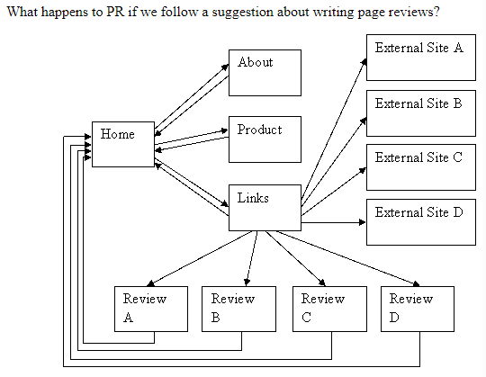

**Answer:**

1. ***Compare the scenario of online delivery service of Bangladesh vs worldwide in this pandemic situation. What is your opinion to improve this scenario in this current pandemic situation for Bangladesh? Justify your suggestion with proper information and infrastructure that currently Bangladesh may use of it.***

***[Use proper citation of your information and make your own graph (if any) by collected data from the web.] [Maximum 1000 words]***

**Answer:**

Corona Virus first started in China in December. It has expanded nearly every corner of the globe. After 3 months later this virus came to our country. After 1 month of lockdown the agricultural system and day-to-day necessary products production got affected. People couldn’t go outside due to pandemic and couldn’t buy daily necessities. So, here comes the online delivery system. Not only food but also other things like dress, electric products, cosmetics, medicines etc are also delivered by some online companies. E-commerce sites of the worldwide also feels corona virus pinch. The global financial and economic growth suddenly falls apart due to corona virus.

The delivery scenario of Bangladesh and other countries of the world is bit different.

World’s online delivery companies are Uber eats, Grubhub, Just Eat, Deliveroo, Delivery.com, OLO, FedEx, DHL etc.

In Bangladesh Sheba.xyz, Daraz, perfee, ChalDaal, Shawpno, AjkerDeal.com, Rokomari.com, Bikroy.com, ClickBD etc are popular online courier and delivery companies.

## World delivery companies scenario we can see:

Today, many world’s leading food delivery companies are collaborating with AI technology companies to deliver food with robots, drones and self-driving cars. These use GPS and camera to determine the optimum route to ensure quick delivery of food to the customers.  The use of Big Data is also gaining popularity among takeaway food delivery service providers. By collecting and analyzing information such as purchasing history, road traffic, market trends, and online reviews, the food delivery companies will be able to precisely estimate customer’s food preferences and delivery time.

* **AMAZON:**

-Due to pandemic Amazon and other companies decided to launch side-walking Robot and drone.

-Amazon also warned shipping times are slower due to the high demand for online shopping.

-Amazon Prime members typically get orders within one or two days.

-Services like Prime Now and the Amazon Fresh grocery delivery service reported limited availability for several days.

-The increased demand threatens to pose logistical challenges for Amazon. The company has been working to avoid disruptions in the supply chain, while some factories in China and elsewhere remain offline.

* **McDonald’s** :

-Some of the world’s biggest food chains using the apps, such as McDonald’s and Wagamama, have closed in the United Kingdom for the time being. .

* **UPS and FedEx:**

- UPS and FedEx are also moving toward electric vehicles, including cargo e-bikes.

* **Uber**:

-Uber is pledging 10million free rides and deliveries of food for frontline healthcare workers, seniors, and people in need around the world.

-Uber people are providing free meals on Uber Eats to first responders and healthcare workers in US and Canada.

-Uber has waived the Delivery Fee for the more than 100,000 independent restaurants across US and Canada on Uber Eats.

-Uber Freight is donating the delivery of essential goods like food, face masks, and hospital beds to healthcare facilities and food banks across US and Canada.

-Uber Health is providing free transportation for frontline healthcare workers, helping them get to and from patients’ homes.

* **Deliveroo:**

**-**Deliverro have issued guidance on how their riders can stay safe and make food deliveries without touching restaurant packaging.

* **Burger King:**

-Burger King have also reopened some drive-through restaurants – [prompting long trafficqueues](https://www.bbc.co.uk/news/uk-england-52746790).

## Bangladesh’s Delivery Companies Scenario:

E-commerce sites in Bangladesh are experiencing a surge in online orders -- mainly for grocery items, over the counter medicines, and other daily essentials amid the ongoing corona virus pandemic.

However, due to the fear of getting infected by the deadly virus, most of them who deliver goods to the doors of consumers are not willing to work.

* **Uber eats** : Uber eats in Bangladesh shut down their business.
* **Pathao:**
* **Pathao** have relaunched Pathao "Tong", an on-demand essentials delivery service, in response to the coronavirus pandemic.
* Pathao Users can also order non-prescription and OTC medicine from Pathao "Pharma”. They are dedicated to delivering the items to customers’ doorsteps in less than 40 minutes.
* Pathao have also taken the decision to enable contactless delivery and to ensure that the payment is done digitally. Their delivery agents have been trained to stand at least three feet away from the door of a household they are delivering at.
* **HungryNaki :**

- Hungry nakiproveds mask and other safety equipments to their delivery agents.They also disinfect the food bag before and after delivery.

* **Foodpanda**:

- FoodPanda has also partnered with Lifebuoy to give out Lifebuoy handwashes to all riders and restaurant partners to ensure regular hand washing is practiced both at work and at home.

- FoodPanda will be pledging 20,000 free meals for first responders and healthcare workers as well.

* **DARAZ**:

-DARAZ took all possible steps to ensure stability in prices of medical supplies.

-Daraz have also taken measures and provided guidelines to ensure delivery personnel wearing gloves for safer cash handling at the time of delivery.

* **SHWAPNO:**

-Shwapno is working hand in hand with farmers in remote areas to source produces directly from them so that they get a fair price.

-Shwapno recruits 300 staff amid Covid-19 pandemic.

- Shwapno recruits third gender people as their delivery agents.

* **ChalDal.com** :

-Chaldal.com only open their online payment option. They’re not supporting cod(cash on delivery)

- Chaldal, who keeps the deliverymen on their payroll, are paying them a 50 percent bonus on salaries.

How to improve the scenario of online delivery System due to pandemic in Bangladesh:

1. Proper hand sanitization and protection: During this pandemic the first foremost thing to do is proper sanitization. Companies should trained and give them mask, gloves and other items for security of the delivery agents.
2. The quality of products: The quality should be up to the mark. Because of the pandemic online service provider shouldn’t take the advantage of the customer.
3. Price and Vat: The price and VAT should not be so high. Most companies taking high amount of Vat which is also another big issue for some customer.
4. Safe packaging and shipment: The packaging and the food bag must be disinfect and sanitize.
5. Leave delivery Instructions: After delivery leave instructions.
6. Over tip delivery agent: This is precarious, low-waged employment without benefits and such, and these are difficult financial times for many.
7. Fast Response and quick delivery: There should be an option as emergency medicine and quick delivery.
8. Social Media Advertising: More online service companies should be advertise their services on social media.
9. Launch more fun product: A marketing campaigns with headlines that reference “staying busy,” for example, can be a great way to help customers find fun products you sell that they might not have thought of as a way to help fill the time.
10. Limiting purchasing Quantity: Everyone should get their products. Consider limiting purchase quantities of items that will be in high demand so that everyone has a chance to get some.
11. Reconsider Discount strategy: Consider offering free or low cost digital products. This could range from educational activities for kids and adults alike related to the product line, digital content and lighthearted entertainment from your team and more.
12. Gift Cards: Selling promotional gifts can give companies opportunities to build longer term relationships with customers
13. Take device preferences into consideration: People are staying at home and they may use their PC a bit more than their mobile. Make sure to include this in your strategy and optimize budget allocation per device.
14. PHONE CODE: Use phone code rather than signature receiver form.
15. Flexibility in delivery: Do not focus your pillars on just one carrier, but look at several options. Switch, for example, when a carrier cannot handle the crowds or cannot reach a certain destination. You can also look into alternative local carriers like bike couriers as an alternative.
16. Website Management: Make sure the website is running at optimum capacity and it is not overloaded and does not crash.
17. Collaboration with an offline retailer: Offline retailers are significantly struggling in these times. By working together you can both increase your sales and broaden your target
18. Find back-up or alternative suppliers
19. Expand product range
20. Stay in touch with the retailers.

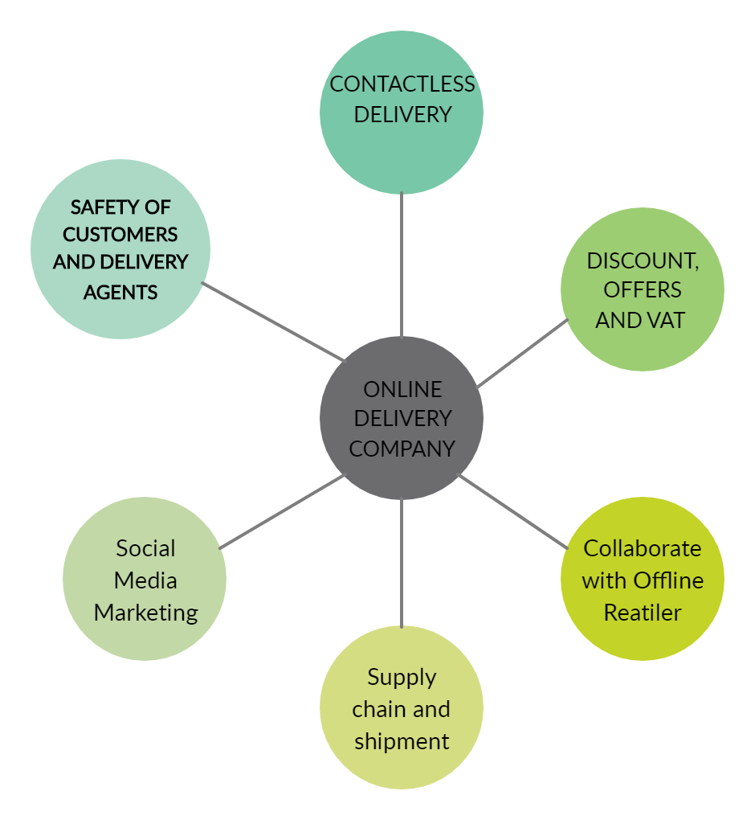

Figure: Flowchart of online delivery system

However, broadband connectivity may be a hurdle if we go deep into the country, where these companies want to cast their net. There will be challenges, too. It will be a cultural shift for consumers to become comfortable making online payments. Even physical infrastructure of roads for last-mile delivery is an issue, especially in our country.